**SECTION A**

1. Divide: 72 ÷2

1. Subtract:  - 

1. Describe the unshaded part.

**A B**

1. Given that x = 2 and y = 3x. Find the value of y3 x 2x.

1. Subtract: 4 2 2 five

- 3 4 five

1. Find the sum of the integers shown on the number line.

b

a

D:\CORNERSTONE 2018\all drawings others\number line 1.PNG

1. Convert 36 square metres into square centimetres.
2. The price of 1kg of meat increased from shs. 10,000 to shs. 12,000. By what percentage did the price of the meat increase?
3. Express 21:50 hours in 12 hour clock system.

1. The average weight of 5 pupils is 30kg when their teacher joins them their average weight becomes 36kg. Find the weight of the teacher.

1. Bisect angle ABC.

**C**

**B**

**A**

1. A car takes 2 hours to cover a distance at 30km/hr. How long will it take to cover the same distance at 20km/hr?

1. The perimeter of a quadrant is 12.5cm. Find its radius (Take π = )

1. Teacher Kafuna withdrew a bundle of ten thousand shilling notes from the bank numbered from AP322520 to AP322549. How much money did he withdraw?

1. Solve the inequality: **-**3 – 2y < 3

1. A trader bought 10kg of sugar and packed it in kg packets. How many packets did the trader pack?

1. The product of two numbers is 216 and their GCF is 6. Find the LCM of the two numbers.
2. James is 3 times as old as John. Their total age is 52 years. How old is John.

1. Use distributive property to work out (30 x 64) – (30 x 54)

1. Find the next number in the sequence; 1, 2, 10, 37, ______

**SECTION B**

1. In a P.7 class at God’s Love P/S, 8x pupils like Science only (S), 2x pupils like both Science and English and 14 x pupils like English € while (x+1) pupils like none of the two subjects.
2. Complete the venn diagram below.

S E

___ 2x ___

s+1

1. Find the value of x if n(SE) = 43
2. Find the number of pupils in the class.
3. a)Simplify: 

b) Express 0.5454… as a common fraction.

1. A man prepared tea in that milk was 40% more than water. If water was 12litres only in the tea. How much tea was prepared?

1. A lorry weighs 22000kg when empty and it weighs 367,600kg when full of sand. Find the weight of the Lorry in kilogrammes when it is  full of sand. (6marks)

1. A water tank at Kidunduma P/S is  full of water. When 6,000 litres of water is added it becomes full.
2. How many litres of water does it contain when it completely full?

1. Find of the tank when full.
2. A motorist left town A for town B at a speed of 70km/hr. He returned through the same route at an average speed of 50km/hr. The whole journey to and fro took 6 hours.
3. Calculate the distance between town A and town B.

1. How long did his return journey take?

1. a) Solve:  = 

b) Solve:  + x = 10

1. The table below shows marks scored by P. 7 pupils at Kasangati Primary School. Use it to answer the questions that follow.

|  |  |  |  |  |  |
| --- | --- | --- | --- | --- | --- |
| Marks | 65 | x | 80 | 85 | 90 |
| No. of pupils | 2 | 3 | 1 | 2 | 2 |

1. How many pupils did the test?

1. Find the value of X if the average mark was 77.

1. Calculate the range of marks.

1. Study the figure below and answer the questions

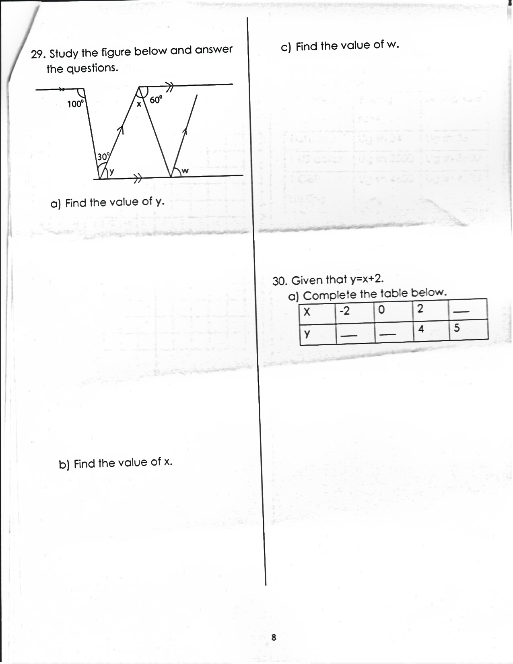

1. Find the value of y.

1. Find the value of x.
2. Find the value of w.

1. Given that y = x + 2
2. Complete the table below

|  |  |  |  |  |
| --- | --- | --- | --- | --- |
| X | -2 | 0 | 2 | ___ |
| Y | ___ | ___ | 4 | 5 |

1. Plot the above co-ordinates on the grid below

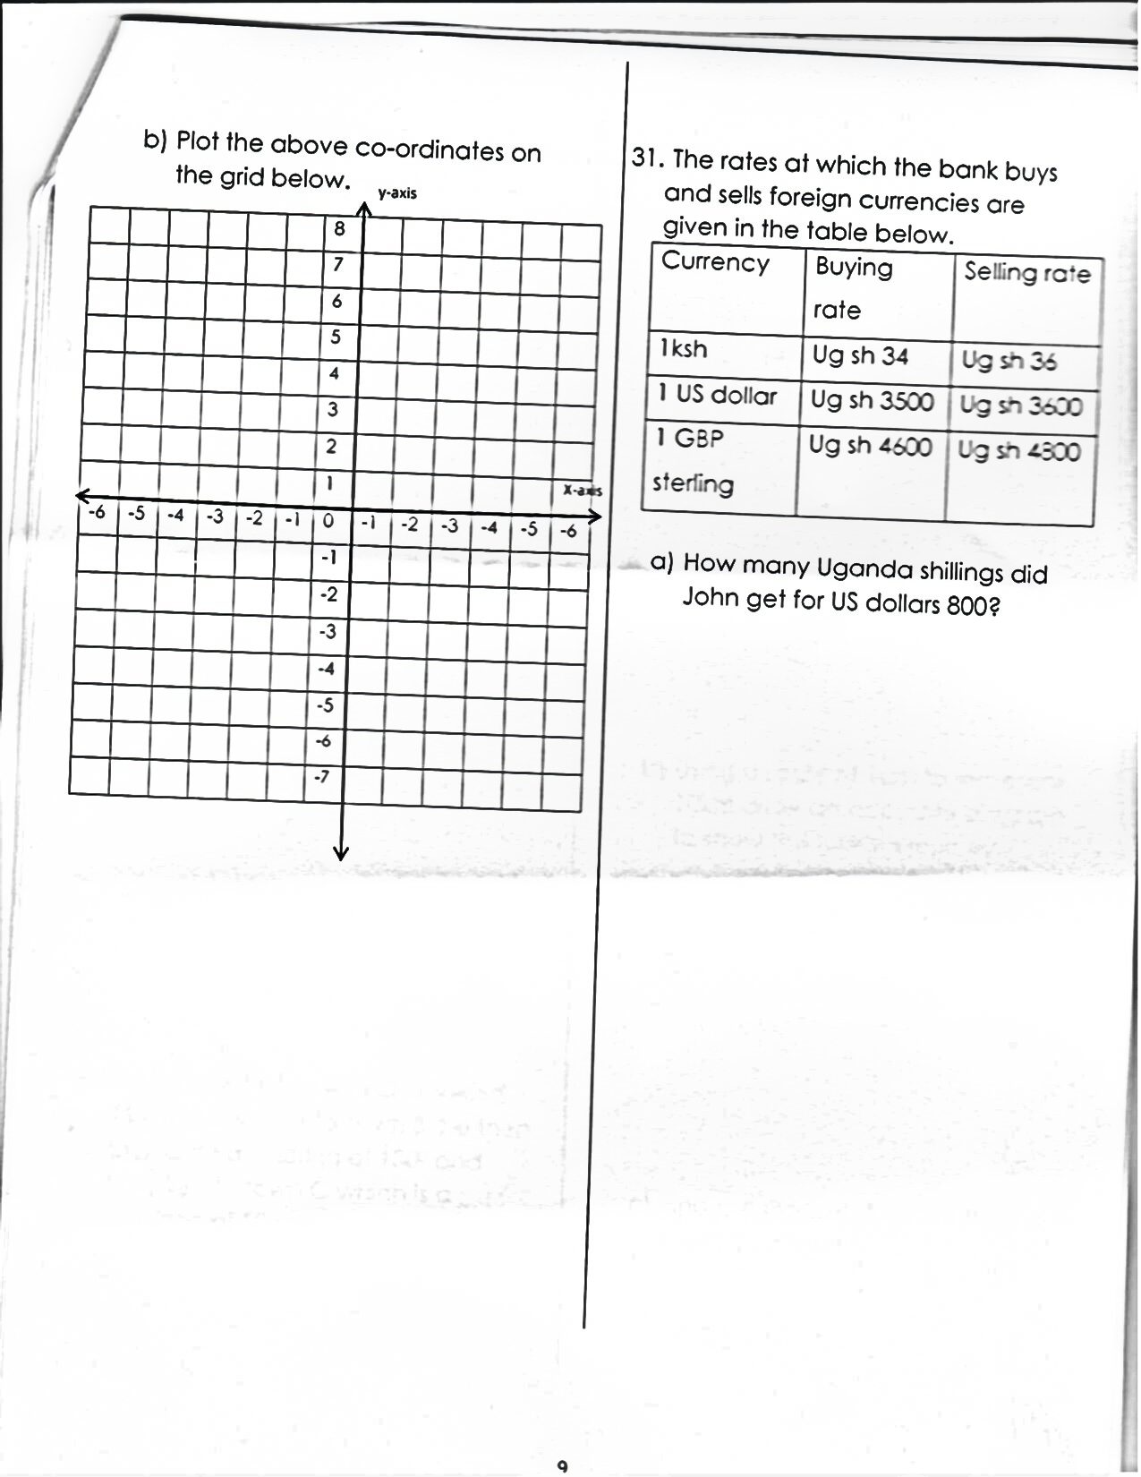

1. The rates at which the bank buys and sells foreign currencies are given in the table below.

|  |  |  |
| --- | --- | --- |
| **Currency** | **Buying rate** | **Selling rate** |
| 1ksh | Ug shs.34 | Ug sh 36 |
| 1 Us dollar | Ug sh. 3500 | Ug sh 3600 |
| 1 GBP sterling | Ug Sh. 4600 | Ug sh 4800 |

1. How many Uganda shillings did John get for US dollars 800?

1. If a trader had us dollars 3600 and wanted to exchange it for GBP sterling, how many GBP did she get?

1. A tourist left town A and travelled 46km Westwards to Town B, he then turned on a bearing of 1500 and travelled to town C which is a distance of 50km?
2. Draw a sketch diagram to show the tourists journey

1. Using a scale of 1cm to represent 10km draw an accurate diagram to show the tourist’s journey.

1. Find the shortest distance from town C to town A.